Business Analytics Case Study Report

Telco Customer Churn Analysis: Identifying Factors Influencing Customer Attrition

1. Introduction
Telecommunication companies face the challenge of customer churn, where customers discontinue their services and move to competitors. Understanding the reasons behind customer churn allows businesses to develop effective retention strategies and improve customer satisfaction.
This project analyzes the Telco Customer Churn dataset to identify factors contributing to customer attrition and provide data-driven recommendations that can help reduce churn.

2. Business Problem Statement
The main business problem addressed in this analysis is:
Why are customers leaving the telecommunications company, and which factors contribute most to customer churn?
The analysis aims to identify customer characteristics and service factors associated with churn, enabling the company to develop targeted retention strategies.

3. Dataset Description
Dataset: Telco Customer Churn Dataset
Source: Kaggle
Original Records: 7,043 customers
After Cleaning: 7,032 customers
Number of Features: 21 columns
The dataset contains information about:
Customer demographics
Account information
Services subscribed
Contract type
Payment methods
Monthly and total charges
Customer churn status

4. Data Analysis Process
The analysis was performed using:
Python
Pandas
NumPy
Matplotlib
Seaborn
Power BI

Data Cleaning Steps:
Checked dataset structure and data types
Assessed missing values
Converted TotalCharges into numeric format
Removed incomplete records
Verified cleaned dataset

Exploratory Data Analysis:
The following analyses were performed:
Churn distribution analysis
Contract type vs churn
Monthly charges vs churn
Customer tenure vs churn
Payment method vs churn

5. Key Findings

Overall Churn Rate
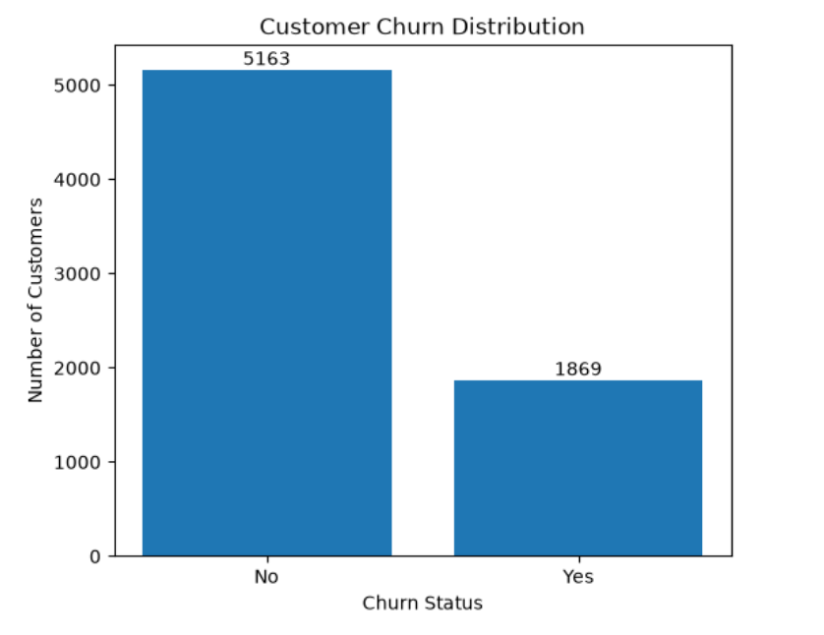
Analysis showed:
Total customers: 7,032
Retained customers: 5,163 (73.4%)
Churned customers: 1,869 (26.6%)
Finding:
Approximately one-quarter of customers leave the company, highlighting the need for effective retention strategies.

Contract Type and Churn
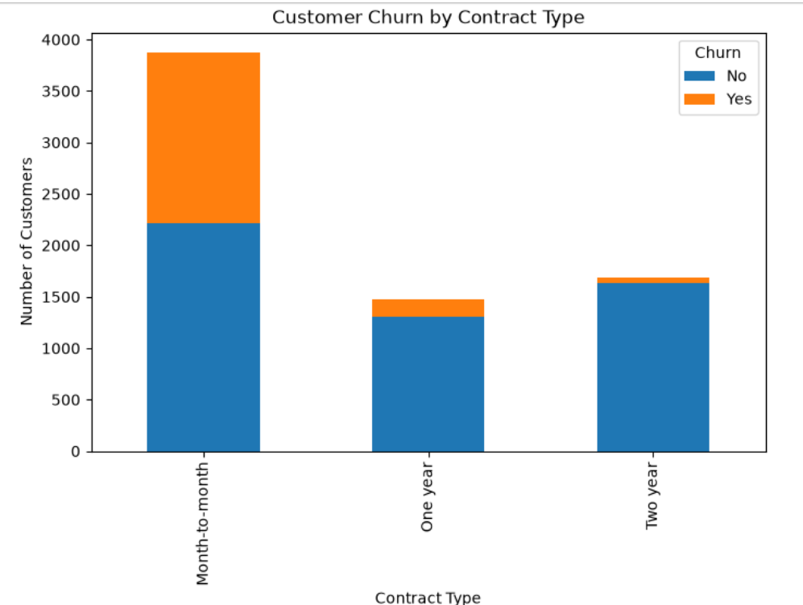
Finding:
Month-to-month contract customers have the highest churn rate.
Month-to-month customers are significantly more likely to leave.
Two-year contract customers show the lowest churn.
Business Insight:
Customers with longer commitments are more loyal and less likely to churn.

Monthly Charges and Churn
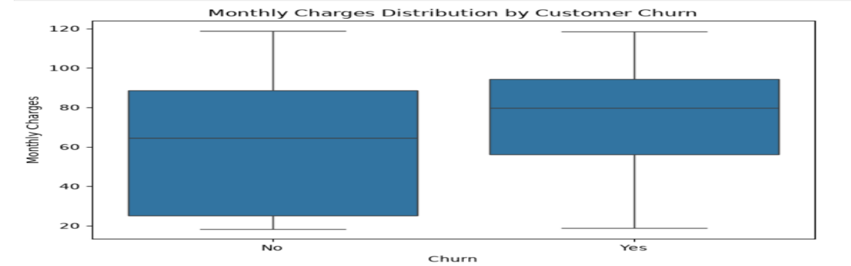
Finding:
Average monthly charges:
Retained customers: ~61.31
Churned customers: ~74.44
Business Insight:
Customers paying higher monthly charges may perceive lower value, increasing their likelihood of leaving.

Customer Tenure and Churn
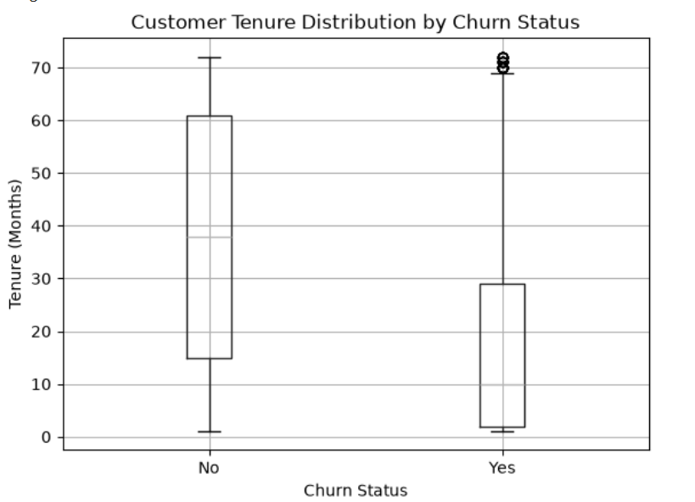

Finding:
Customers with shorter tenure are more likely to churn.
Business Insight:
The early customer journey is a critical period where improved onboarding and engagement can reduce churn.

Payment Method and Churn
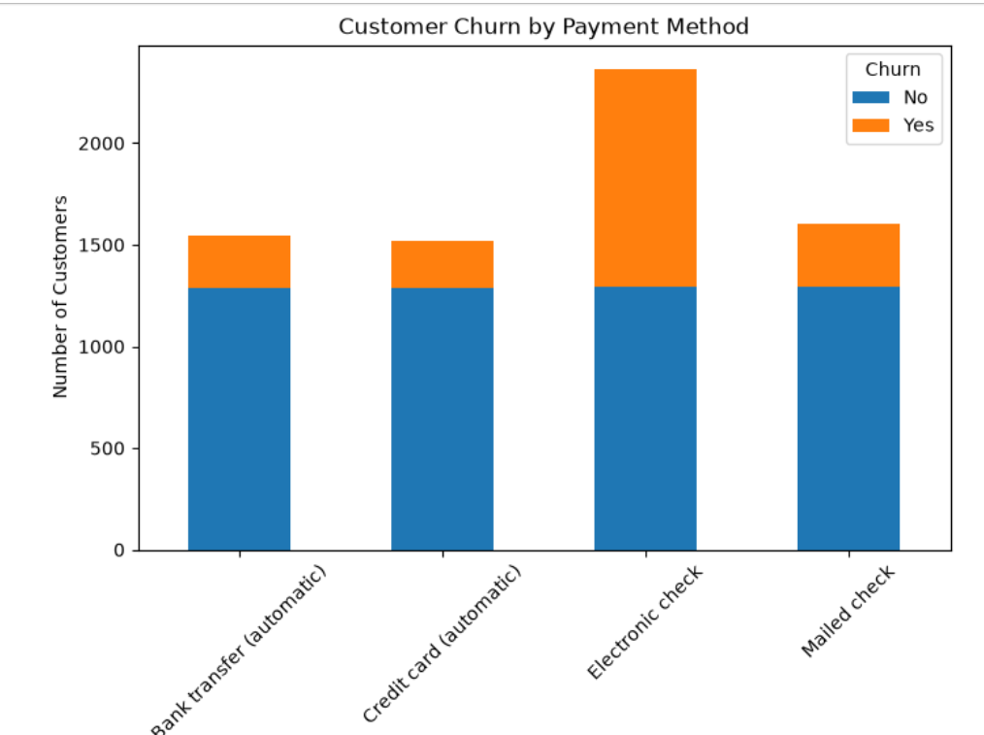
Finding:
Electronic check users recorded the highest churn levels.
Interactive Dashboard Overview
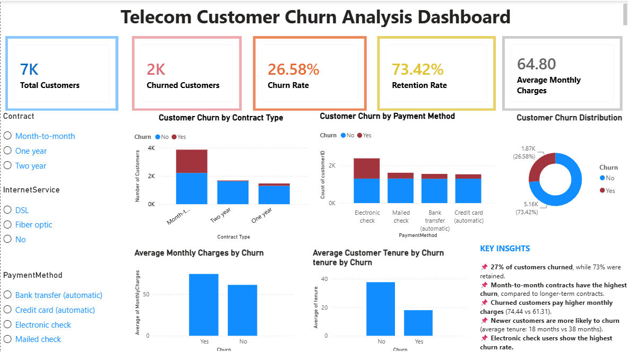
Dashboard Overview:
An interactive Power BI dashboard was developed to summarize the key findings of the analysis. The dashboard includes KPI cards showing Total Customers, Churned Customers, Churn Rate, Retention Rate, and Average Monthly Charges. It also contains interactive visualizations of churn by contract type, payment method, tenure, and monthly charges, with slicers that allow users to filter the data dynamically for deeper analysis.
Business Insight:
Payment experience and convenience may influence customer satisfaction.

6. Business Insights
From the analysis, the major churn drivers identified are:
Contract type
Short-term contracts are associated with higher churn.
Customer tenure
New customers require stronger engagement strategies.
Monthly charges
Higher costs may contribute to dissatisfaction.
Payment method
Some payment methods may create friction in the customer experience.

7. Recommendations

1. Encourage Long-Term Contracts
Provide incentives such as discounts or loyalty benefits for customers who move from month-to-month contracts to yearly plans.

2. Improve Customer Onboarding
Develop early engagement programs for new customers during their first months.

3. Review Pricing Strategies
Analyze pricing plans and provide better value options for high-paying customers.

4. Improve Payment Experience
Investigate issues affecting customers using electronic checks and encourage easier payment options.

5. Develop Customer Retention Programs
Use churn risk indicators to identify customers likely to leave and provide personalized offers.

8. Conclusion
This analysis identified important factors influencing customer churn, including contract type, tenure, monthly charges, and payment methods. The findings provide valuable insights that can help the company implement targeted retention strategies and improve customer loyalty.

